- Program ID : VS001MA1

- Display Layout
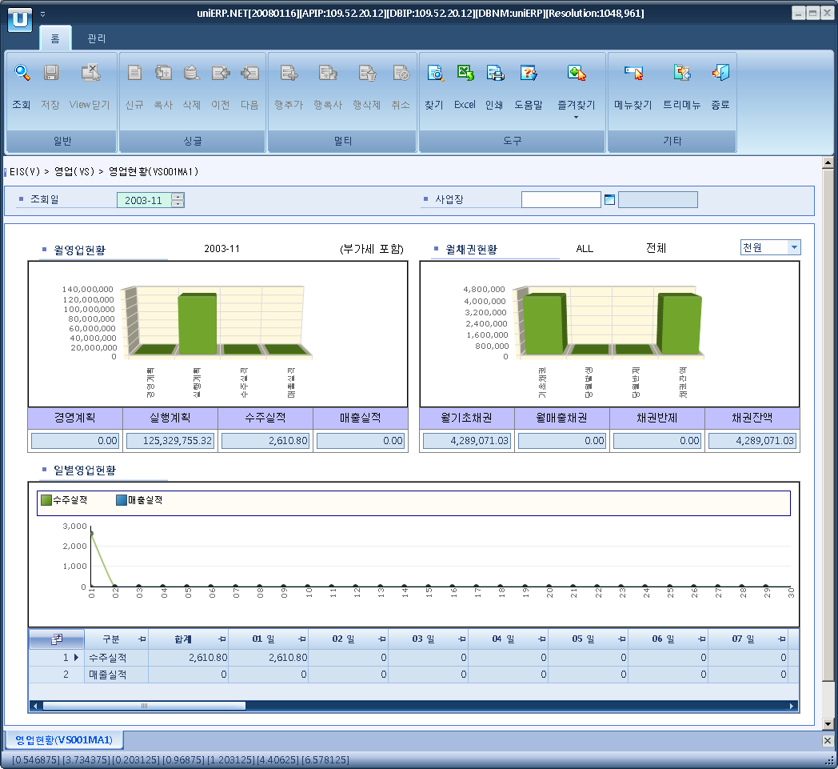

- Event flow
- Click Query button
- OnFncQuery -> DbQuery -> DataChange
- Display Unit combo change
- uniCombo1_ValueChanged -> DataChange

- SQL Statements
- Monthly operation plan
SELECT z.amt
FROM (SELECT SUM(a.amt_loc) AS amt
FROM s_sp_item_by_bp a(nolock)
INNER JOIN s_sp_period_info b(nolock)
ON a.sp_period = b.sp_period
AND a.sp_type = b.sp_type
INNER JOIN b_sales_grp c(nolock)
ON a.sales_grp = c.sales_grp
INNER JOIN b_cost_center d(nolock)
ON c.cost_cd = d.cost_cd
WHERE CONVERT(CHAR(4), b.sp_year) + RIGHT('0' + CONVERT(VARCHAR(2), b.sp_month), 2) = @strYyyyMm
AND d.biz_area_cd LIKE @biz_area_cd
AND a.cfm_flag = 'Y'
AND a.sp_type = 'M') z

- Monthly execution plan
SELECT SUM(z.amt)
FROM (SELECT SUM(a.amt_loc) AS amt
FROM s_sp_item_by_bp a(nolock)
INNER JOIN s_sp_period_info b(nolock)
ON a.sp_period = b.sp_period
AND a.sp_type = b.sp_type
INNER JOIN b_sales_grp c(nolock)
ON a.sales_grp = c.sales_grp
INNER JOIN b_cost_center d(nolock)
ON c.cost_cd = d.cost_cd
WHERE CONVERT(CHAR(4), b.sp_year) + RIGHT('0' + CONVERT(VARCHAR(2), b.sp_month), 2) = @strYyyyMm
AND d.biz_area_cd LIKE @biz_area_cd
AND a.cfm_flag = 'Y'
AND a.sp_type = 'E'
UNION ALL
SELECT SUM(a.plan_amt) AS amt
FROM s_item_sales_plan a(nolock)
WHERE a.sp_year + a.sp_month = @strYyyyMm
AND biz_area LIKE @biz_area_cd
and a.cfm_flag = 'Y') z

- Monthly S/O result
SELECT SUM(a.net_amt_loc + a.vat_amt_loc)
FROM s_so_hdr a
WHERE a.so_dt BETWEEN @strYyyyMm + '01'
AND DATEADD(DAY, -1, DATEADD(MONTH, 1, @strYyyyMm + '01'))
AND a.cfm_flag = 'Y'
AND a.to_biz_area LIKE @biz_area_cd

- Monthly sale result
SELECT SUM(a.bill_amt_loc + a.vat_amt_loc), SUM(a.collect_amt_loc)
FROM s_bill_hdr a
WHERE a.bill_dt BETWEEN @strYyyyMm + '01'
AND DATEADD(DAY, -1, DATEADD(MONTH, 1, @strYyyyMm + '01'))
AND a.post_flag = 'Y'
AND a.biz_area LIKE @biz_area_cd

- Monthly A/R status
SELECT SUM(CASE WHEN z.qdate < @strYyyyMm + '01' THEN z.ar_amt - z.cls_amt - z.dc_amt - z.adjust_amt ELSE 0 END),
SUM(CASE WHEN SUBSTRING(z.qdate,1,6) = @strYyyyMm THEN z.ar_amt ELSE 0 END),
SUM(CASE WHEN SUBSTRING(z.qdate,1,6) = @strYyyyMm THEN z.cls_amt ELSE 0 END),
SUM(CASE WHEN SUBSTRING(z.qdate,1,6) = @strYyyyMm THEN z.dc_amt + z.adjust_amt ELSE 0 END),
SUM(z.ar_amt - z.cls_amt - z.dc_amt - z.adjust_amt)
FROM (SELECT a.ar_no AS ar_no, CONVERT(CHAR(8), a.ar_dt, 112) AS qdate, a.ar_loc_amt AS ar_amt,
0 AS cls_amt, 0 AS dc_amt, 0 AS adjust_amt
FROM a_open_ar a(nolock)
WHERE a.ar_dt <= DATEADD(DAY, -1, DATEADD(MONTH, 1, @strYyyyMm + '01'))
AND biz_area_cd LIKE @biz_area_cd
AND a.ar_type = 'AR'
UNION ALL
SELECT b.ar_no, CONVERT(CHAR(8), b.cls_dt, 112), 0, b.cls_loc_amt, b.dc_loc_amt, 0
FROM a_cls_ar b(nolock)
INNER JOIN a_open_ar a(nolock)
ON a.ar_no = b.ar_no
AND a.ar_type = 'AR'
AND b.cls_dt <= DATEADD(DAY, -1, DATEADD(MONTH, 1, @strYyyyMm + '01'))
AND a.biz_area_cd LIKE @biz_area_cd
UNION ALL
SELECT b.ar_no, CONVERT(CHAR(8), b.adjust_dt, 112), 0, 0, 0, b.adjust_loc_amt
FROM a_ar_adjust b(nolock)
INNER JOIN a_open_ar a(nolock)
ON a.ar_no = b.ar_no
AND a.ar_type = 'AR'
AND b.adjust_dt <= DATEADD(DAY, -1, DATEADD(MONTH, 1, @strYyyyMm + '01'))
AND a.biz_area_cd LIKE @biz_area_cd) z
- Monthly S/O trend
SELECT SUBSTRING(CONVERT(VARCHAR(8), a.so_dt, 112), 7, 2), SUM(a.net_amt_loc + a.vat_amt_loc)
FROM s_so_hdr a
WHERE a.so_dt BETWEEN @strYyyyMm + '01'
AND DATEADD(DAY, -1, DATEADD(MONTH, 1, @strYyyyMm + '01'))
AND a.cfm_flag = 'Y'
AND to_biz_area LIKE @biz_area_cd
GROUP BY SUBSTRING(CONVERT(VARCHAR(8), a.so_dt, 112), 7, 2)

- Monthly Sale trend
SELECT SUBSTRING(CONVERT(VARCHAR(8), a.bill_dt, 112), 7, 2), SUM(a.bill_amt_loc + a.vat_amt_loc)
FROM s_bill_hdr a
WHERE a.bill_dt BETWEEN @strYyyyMm + '01'
AND DATEADD(DAY, -1, DATEADD(MONTH, 1, @strYyyyMm + '01'))
AND a.post_flag = 'Y'
AND biz_area LIKE @biz_area_cd
GROUP BY SUBSTRING(CONVERT(VARCHAR(8), a.bill_dt, 112), 7, 2)

